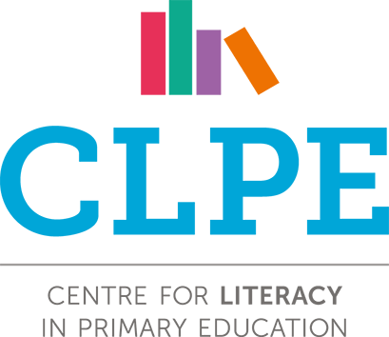

Please Note that over the course of a year the English curriculum should cover a balance of Fiction, Non-Fiction, Poetry and Picture Books.
This is not an exhaustive list.
Log of Core Texts by Year from the power of reading

Reception | Year 1 | Year 2 | Year 3 | Year 4 | Year 5 | Year 6
Fiction | Fiction | Fiction | Fiction | Fiction | Fiction | Fiction
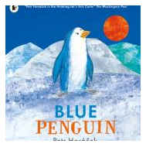  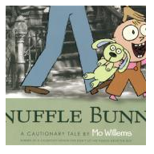  Petr Horáček’s book focuses on themes around identity and belonging. Blue Penguin is not accepted by his community because he looks different from them.  Trixie goes with her dad to the Laundromat but on the way home – crisis strikes! What is wrong with Trixie?  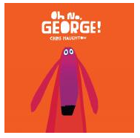  Harris is going out and leaving George the dog at home alone. Can he be trusted to behave himself? Can George trust himself? His escapades are described in a patterned text with a repetitive refrain which encourages prediction and invites participation from listeners.  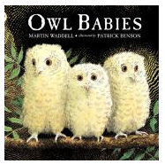  Separation is one of the big traumas of childhood. In this utterly simple yet deeply moving picture book all that happens is that three owlets are left alone whilst their mother goes off into the night to hunt for food.  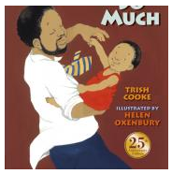  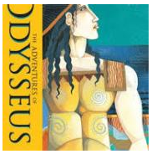  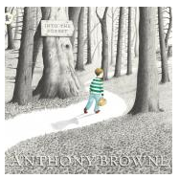  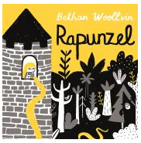  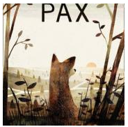  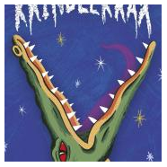  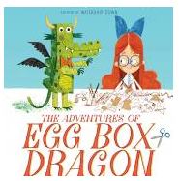  A large and loving picture book in which aunts, uncles, cousins and grandparents come to the baby’s house for a surprise birthday party for his Dad. They all love the baby SO MUCH that he falls asleep, exhausted from all the attention.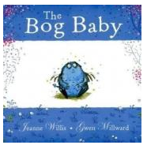  Peter’s father goes away to war, taking him to stay with his grandfather before leaving. Before he does this, they drive Peter’s tame fox, Pax, many miles away and leave him to return to the wild. Alternate chapters focus on Peter and Pax, each indicated by a silhouette head. Neither boy nor fox wants to be parted and each embarks on an emotional and physical journey. Will reunion be possible?  Adapted from an oral retelling of this epic, this version of the travels and trials of Odysseus reads aloud well. Framed by the story of Penelope and her long wait for the return of her husband, we hear the gory tale of one-eyed Cyclops, marvel at Circe’s ability to change men into pigs, and are moved by Odysseus’s reunion with his son.  An action-packed story in which the weedy central character, Ruskin Splinter, becomes a hero. He outwits the monster Krindlekrax which has been terrorising Lizard Street and tames Elvis, the local bully. Characters in Philip Ridley’s stories usually have catchphrases, and these can become refrains to be joined in with when the books are read aloud.  This picture book with its highly detailed illustrations provides a great deal for classes to explore. The gaps in the main storyline enable children to relate it to their own experiences. The intertextuality through rich fairy tale references provides lots of opportunities for making links with the children’s knowledge of other texts.  Arts and crafts literally come to life when Emma brings home a dragon she has constructed from a range of materials – shiny bicycle reflectors, black bin liners, thick wire and, predominantly, cut up egg boxes. A night under the moon awakens the Egg Box Dragon who quickly becomes famous for his ability to find lost objects, eventually coming to the notice of the Queen.  A pared back and twisted take on the traditional tale told with humour to be gleaned from reading the pictures. It begins with Rapunzel, here portrayed as a child, already encased in the tower without the back story explaining how she came to be there and reaches a conclusion in which she makes a joyful escape without the aid of a prince.  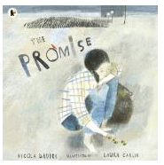  This is a magical story with a serious message about what it means to really love something. When two small sisters decide to go fishing in the magic pond, they find something unexpected and much better than a frog or a newt: they find a bog baby. Small and blue with wings like a dragon, the girls love him with a passion and make a pact to make him their secret.  A girl who is hardened by the harsh urban environment that surrounds her is transformed into a guerrilla gardener by the unexpected booty resulting from a mugging.  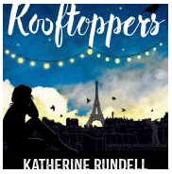  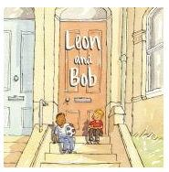  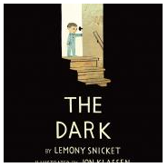  An intriguing statement opens this unusual novel which involves a quest for a missing mother with music playing an important part. Rescued from a shipwreck by scholar Charles, Sophie is brought up by him in an unconventional manner and their mutually supportive relationship, defiant of authority, is delightfully portrayed.  Laszlo is afraid of the dark. The dark lives in the same house as Laszlo but mostly it spends its time in the basement. It doesn't visit Laszlo in his room. Until one night it does. With emotional insight and poetic economy, Lemony Snicket and Jon Klassen bring to light a universal and empowering story about conquering fear.  Leon has an imaginary friend called Bob. A new family moves in next door and Leon makes friends with the child whose name is ... you guessed! A sensitive and beautifully placed story which has great emotional depth and in which words and pictures work intimately together.  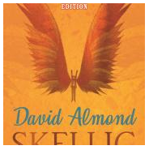  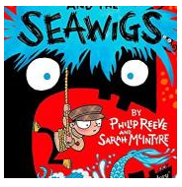  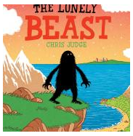  Michael moves to a new house, with his mum and dad and his new baby sister. But soon his sister is ill in hospital, and Michael feels helpless. He explores a broken-down garage in the garden and makes a discovery that will change his life: Skellig, a creature covered in dust and cobwebs. Michael is not sure what this creature is.  Have you heard of the Beasts? No, not many have. That’s because they are very rare. This is the tale of one such Beast, who decides to take a dangerous quest to find others like him. Trekking over mountains and swimming across seas, he comes at last to a great city. There he finds many delights but sadly no Beasts, so he returns home, where a surprise awaits him.  Leon has an imaginary friend called Bob. A new family moves in next door and Leon makes friends with the child whose name is ... you guessed! A sensitive and beautifully placed story which has great emotional depth and in which words and pictures work intimately together.  In her stunning picture book the author/illustrator Francesca Sanna has drawn on experiences she heard about from recent refugees from many countries. The text is easy to read in terms of vocabulary and sentence structure and this apparent simplicity combined with the memorable illustrations have great power to move readers of all ages.  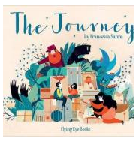  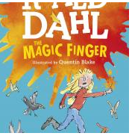  The narrator of this tale is a young girl whose finger has magic powers which become active when she is angry.  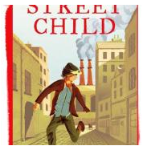  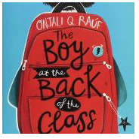  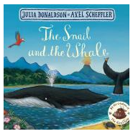  When Ahmet arrives in their class, a group of children are curious to know more about him – where he is from, what language does he speak and where is his family? As they learn more about him – that he is a Kurdish refugee from Syria and that he was separated from his family en route to Britain – their concern for him grows.  A tiny sea snail ‘with an itchy foot’ has a great desire to see the world and hitches a ride on the tail of a humpback whale.  Set in the second half of the nineteenth century, Street child tells the story of a boy called Jim who,after a series of misfortunes, spends time in the workhouse as a child labourer and lives on the streets. The book is based on the true story of an orphan whose plight inspired Doctor Barnado to try to help street children, and led to the founding of his children’s homes.  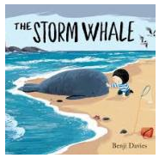    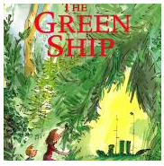  This is the story of a lonely little boy, a whale washed up on the beach and a friendship that will change both their lives forever. Noi and his father live in a house by the sea, his father works hard as a fisherman and Noi often has only their six cats for company. So when, one day, he finds a baby whale washed up on the beach after a storm, Noi is excited and takes it home to care for it.  In this action-driven espionage adventure Alex Rider uses his physical strength and ingenuity, aided, by some highly sophisticated gadgetry, to outwit a conspirator who is obsessively intent on wiping out the whole of the secondary school population of England.  Two children discover a ship made out of trees and bushes. On climbing aboard they enter their own fantasy world, which they share with two equally imaginative adults.  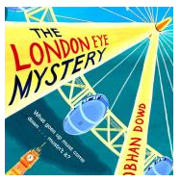  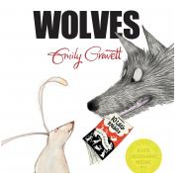  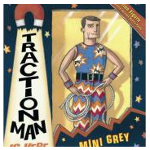  The reader is kept in suspense throughout this humorous adventure which centres around the capital’s landmark visitor attraction. Ted and his sister Kat test out their theories and follow up clues to solve the inexplicable disappearance of their cousin Salim, who failed to re emerge after boarding the London Eye.  This is a carefully crafted and inventive picture book. Children are led into the book by a rabbit who borrows a book about wolves from the library only to discover, belatedly, that a sinister sharp-toothed figure has materialised from the pages.  A boy receives an action figure as a Christmas present and the first half of this inventive picture book shows Traction Man’s exciting adventures. Then comes the visit to Granny who has knitted a green romper suit with matching bonnet for our hero. | 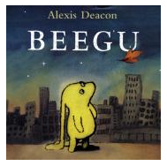  A small creature from outer space lands on Earth accidentally. She finds the Earth creatures unfeeling and unfriendly, until she finds a box of unwanted puppies, and then a school playground full of small creatures who ‘seemed hopeful’. Empathy is evoked by both the brief text and the distinctive illustrations which portray Beegu against the background of a stark and empty urban landscape.  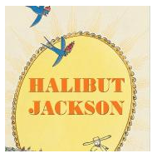  Halibut Jackson is shy and always wears an outfit that enables him to blend in with the environment. Then, one day, the Queen invites him to her birthday party. How will our retiring hero select a suit which is sufficiently chameleon-like? An unexpected outcome results from his choice.    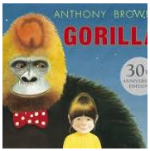  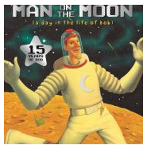  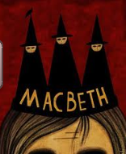  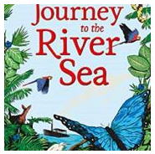  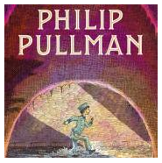  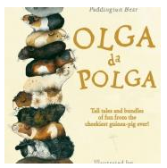  Shakespeare’s shortest tragedy holds attention through its rapid action, sinister atmosphere and convincing psychology. It is peopled with spirits, ghosts and witches and much of the action takes place in dark and shadowy places.  An orphan girl, Maia, leaves her boarding school in England in 1910 to stay with distant relatives who live on a rubber plantation on the banks of the Amazon in Brazil.  Set in an all too believable near future when many parts of England are submerged in water and people drift into gangs, divided due to the scarcity of resources, especially food. Zoe has been left behind on an island which used to be the city of Norwich and discovers a boat which she wants to use to try and find her parents.  In this humorous adventure story we follow Roger as he unwittingly goes from minor to major predicaments, meeting a host of interesting characters along the way. The book has strong links with fairy tales; particularly Cinderella and it can be enjoyed at several levels. The use of newspaper spreads in addition to the narrative provides lots to discuss.  Hannah’s father never seems to have time to spend with her. Disappointed with receiving a toy gorilla for her birthday instead of the real one she hoped for, she enjoys a night time outing with her new toy, who grows to life size. Is it a dream?  Life from a guinea pig’s viewpoint. These stories are charming but also enable deeper thinking and enquiry, for example the chapter ‘Olga Starts a Rumour’ encourages questioning about science and the environment. Olga is an imaginative storyteller – she has a tale about why guinea pigs have no tails.  It’s Bob’s job to keep the Moon clean and tidy. He also welcomes tourist spaceships and gives guided tours. Bob’s daily routine is described in a matter of fact tone, and his disbelief in aliens is frequently referred to. However, the detailed, period pictures, tell a different story and readers will soon spot the little green men lurking in the background. |  | 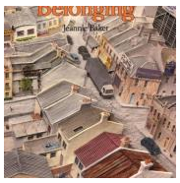  A companion volume to the illustrator’s earlier book Window, this book charts the changes in an urban neighbourhood by viewing it through the same window frame as a baby grows to womanhood and has her own child.  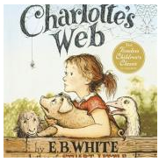  This classic novel for children, first published in 1952, retains its appeal for modern children. It is the story of Fern, a little girl who saves a pig on the family farm from being killed, and the pig’s friendship with a spider who lives alongside him in a barn with the other farm animals. Their lives are woven into the cycle of the seasons and farm life. |  | 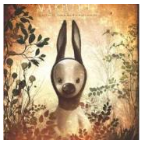  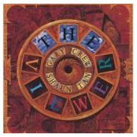  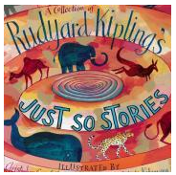  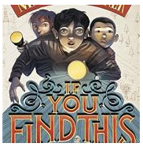  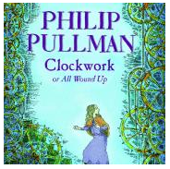  A chilling tale of mechanical beings which has human warmth at its heart. When Fritz begins his story in the tavern on the night when Karl finishes his clockmaker’s apprenticeship, the boundaries between fiction and reality begin to blur. An interesting feature of this novel is the author’s asides to the reader at a number of points.
Non-Fiction | Non-Fiction | Non-Fiction | Non-Fiction | Non-Fiction | Non-Fiction | Non-Fiction
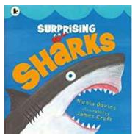  This is an excellent introduction to sharks which will surprise children and ignite their interests in what lurks beneath the sea. The book itself is full of interesting facts about sharks that will challenge the reputation of the shark as a “giant man-eating killer”.  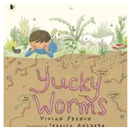A boy learns from observing worms in the garden alongside his grandmother that they are not so yucky after all. He finds out that their eating and excretion habits are helpful in recycling material which is good for the soil and helps plants grow.  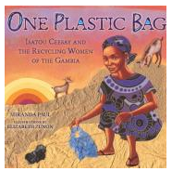  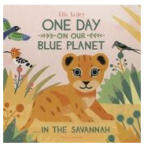  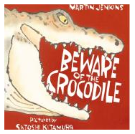  The true story of Isatou Ceesay who saw the problem that the proliferation of plastic bags was causing in her country, the Gambia, contaminating the environment and killing the goats that swallowed them. She collaborated with other local women to crochet thread made from the plastic bags to create purses resulting in a thriving trade and reducing pollution.  A yellow and green palette pervades the early pages of this day in the life of a lion cub, subtly shading into a rosy evening glow and progressing to deep shades of blue as the night falls on the African Savannah. Although the lion cub is the main focus of the visual and written narrative, there is an abundance of local flora and fauna to be found in the illustrations.  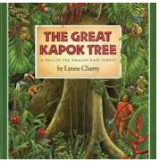  This engaging introduction to the lives of crocodiles begins with a focus on their hunting methods and food consumption, then moves on to their excellent parenting skills. Then comes the big reveal about a link between these two aspects.  Subtitled ‘A Tale of the Amazon Rain Forest’ this picture book expresses clearly by means of vibrant illustrations and a patterned and poetic story, the importance of humans preserving the rainforests and the ecosystems within it for the sake of all who live on this planet. A man is ordered to cut down a great Kapok tree. He begins the task and when he tires, falls asleep at its foot. | 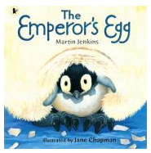  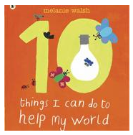  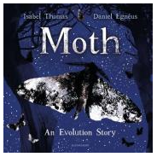  A description of how the male Emperor penguin protects and cares for his young both before and after it is hatched, related in a personalised manner.  This book raises important matters for this generation in a simple and unpreachy way. As the pages are turned, they transform to reveal ten things that everyone can easily do at least one of so as to help conserve the world.  Evolution seen in microcosm through the story of the peppered moth – speckled and freckled and a master of disguise. The poetic text, written by a scientist, combined with mixed media illustrations, demonstrates how this creature has survived through adaptation, responding to natural change and human intervention in the environment. |  | 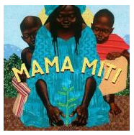  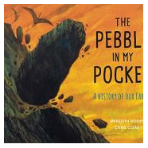  Through Donna Jo Napoli’s lyrical prose and Kadir Nelson’s strikingly beautiful illustrations, the true story of Wangari Muta Maathai, known as “Mama Miti,” is told. In 1977 Mama Miti founded the Green Belt Movement, an African grassroots organisation that has empowered many people to mobilise and combat deforestation, soil erosion and environmental degradation.  This narrative takes the reader into the deep and distant past to witness the formation of the rock from whence came the pebble held by the child in the first picture. A factual text blended with literary language and illustrated with cross-hatched pictures in earthy colours. The life story of a pebble, seen as part of a much wider picture, nothing less than the history of the earth itself. |  | 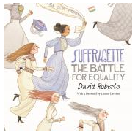  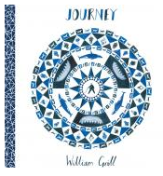  A well-researched account of the women’s suffrage movement in which David Roberts’ enthusiasm for the subject shines through in the illustrations and the writing. Scenes pictured include a diagram of a woman performing martial arts moves on a policeman culminating in him tipping his helmet respectfully.  Young, up-and-coming illustrator William Grill weaves a detailed visual narrative of Shackleton's journey to Antarctica.  His beautiful use of coloured pencils and vibrant hues effortlessly evokes the adventure and excitement that surrounded the expedition. His impeccably researched drawings, rich with detail, fastidiously reproduce the minutiae of the expedition
Poetry | Poetry | Poetry | Poetry | Poetry | Poetry | Poetry
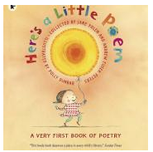  This is a superb selection of over sixty poems by a range of English and American writers – an ideal choice to start the important task of building a class repertoire of favourite poems that everyone knows, shares and delights in.  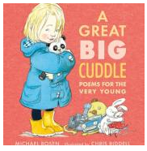  Subtitled ‘Poems for the Very Young’ this is a collection children can have fun and identify with, enabling them to see the point of poetry.  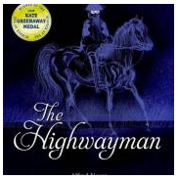  “The Highwayman” is a classic favourite - a poem that tells a good story with powerful imagery and a rhythmic cadence reminiscent of horses' hooves. The story tells of the highwayman's visit to see the beautiful Bess at the old inn (probably the Spaniard's Inn on Hampstead Heath) and of the terrible fate they both meet.  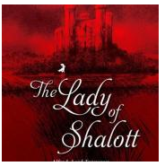  This classic narrative poem by Tennyson is loosely based on Arthurian legend, in which a lady is locked in her tower by a powerful curse and can look at the world only through a mirror. This is a poem of love, shadows and death. The language is beautiful and evocative, and Charles Keeping’s illustrations perfectly complement the poem’s mood. | 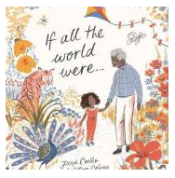  Not to be confused with Joseph Coelho’s well received poem ‘If all the world were paper’ in his CLiPPA winning collection Werewolf Club Rules, this picture book develops one of its central themes – protecting those we love and preserving their memory.  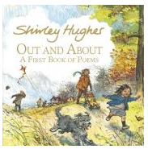  In this book of poetry the seasons are seen from a child’s eye view. Each section opens with a glorious double page spread showing families engaged in a range of seasonally specific activities.  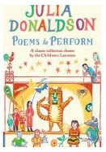  A careful selection of poems both familiar and new, edited by the former Children's Laureate, that lend themselves to being performed in a range of collaborative ways – by two voices, by groups or by a whole class. |  | 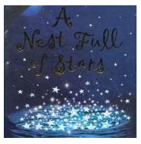  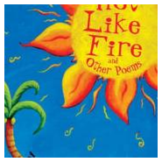  In this collection of poems by James Berry, about half of the poems relate to Caribbean settings and subjects and the rest are poems set in the UK. This teaching sequence focuses both on poems relating to familiar childhood themes (such as friendship and family) and on themes special to the Caribbean.  Valerie Bloom’s sizzling poems, some in Jamaican Creole, some in standard English, bring light and life to diverse aspects of everyday life. |  | 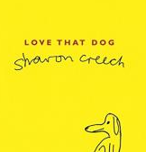  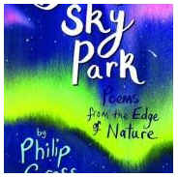  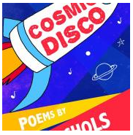  In this narrative poem, Sharon Creech explores what makes a poem and what makes a poet. Love that Dog is a powerful narrative which gradually unfolds, drawing in the reader, making it a very moving and memorable experience.The story takes the form of a dialogue, cleverly developed over the period of a school year, between the student Jack and histeacher Miss Stretchberry.  Subtitled ‘Poems from the Edge of Nature’ the poetry in this collection reaches deep into the past and wide across the world, burrowing into the earth and the sea to discover those creatures less observed rather than those that have more often captured the imaginations of our ‘invasive species, Homo Sapiens’.  This collection whirls us out into the cosmos to dance ‘in the endless El Dorado of stars stars stars’ and back again to ‘that little old blue ball spinning in the corner over yonder’. Nature is personified in many guises. Lady Winter raps out a warning and chastises a cheeky robin.  Read more
Other Possibilities | Other Possibilities | Other Possibilities | Other Possibilities | Other Possibilities | Other Possibilities | Other Possibilities
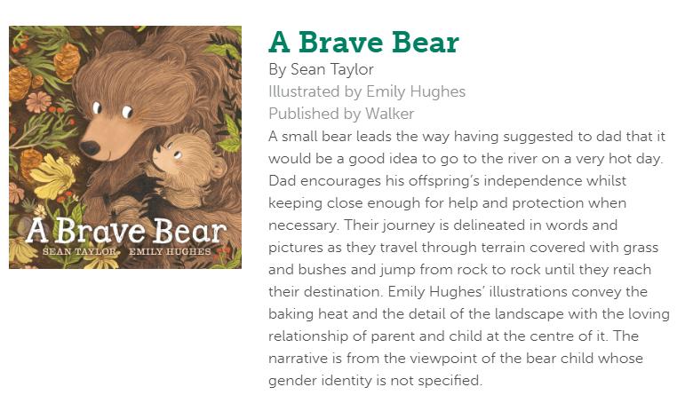  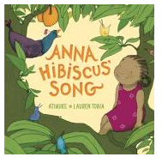  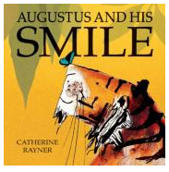  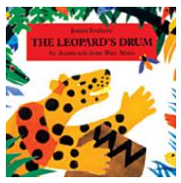  A full list of all books for Reception can be found by following the link below: | 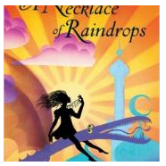  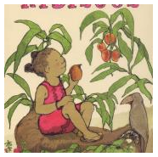  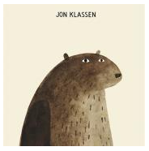  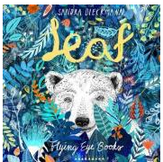  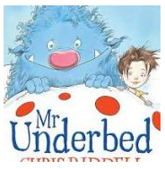  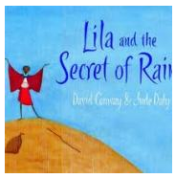  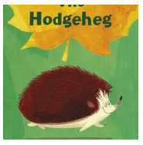  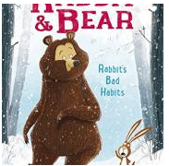 |  | 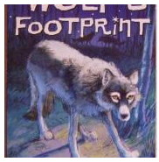  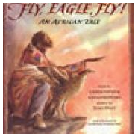  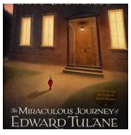  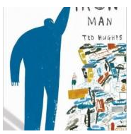  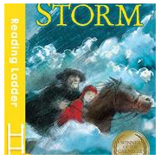  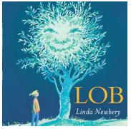  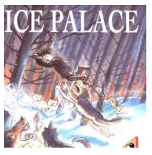  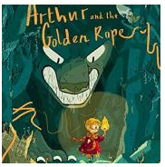 |  | 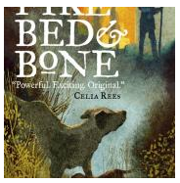  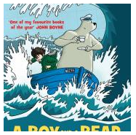  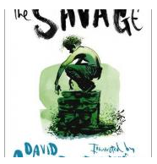  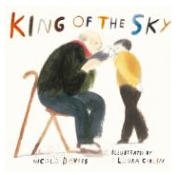  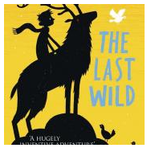    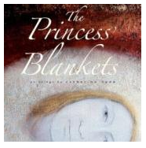  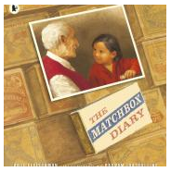
For a complete list of books and synopses click the following link below.
https://clpe.org.uk/powerofreading/books

